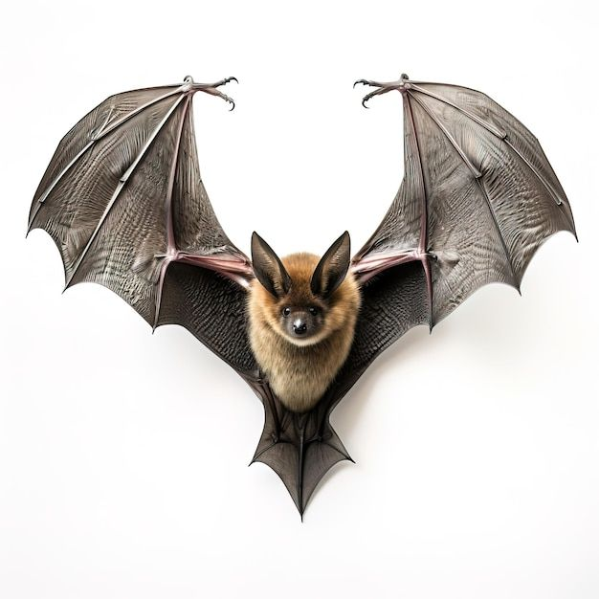
BAT IMAGE
WILLIAM NZUKI

